Experiment 1

Aim: To read an image using Python and convert the image into a gray-scale image using OpenCV.

Algorithm
- Import the OpenCV library.
- Read the input image using cv2.imread().
- Convert the image from RGB/BGR to gray-scale using cv2.cvtColor().
- Display the original image.
- Display the gray-scale image.
- Wait for a key press.
- Close all windows.

Program
import cv2

img = cv2.imread("image.jpg")

gray = cv2.cvtColor(img, cv2.COLOR_BGR2GRAY)

cv2.imshow("Original Image", img)
cv2.imshow("Gray Scale Image", gray)

cv2.waitKey(0)
cv2.destroyAllWindows()

Output
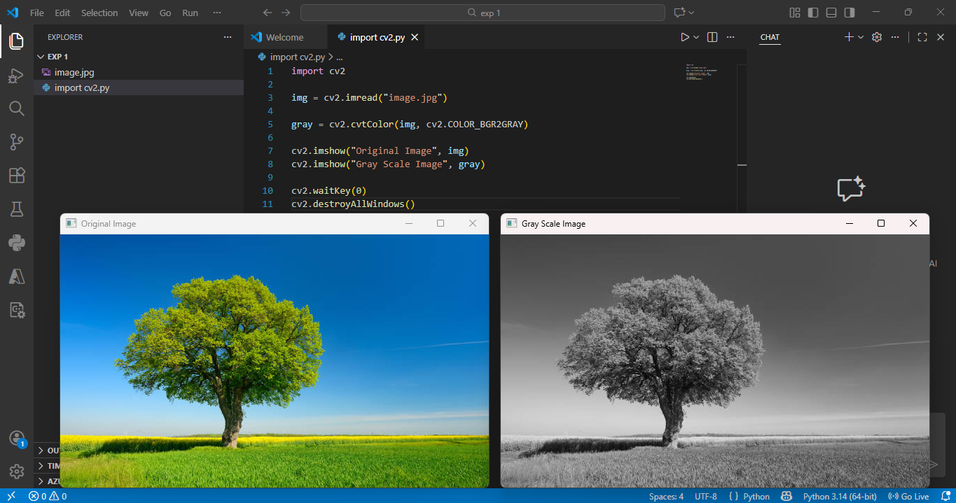

Result: The input image was successfully read and converted into a gray-scale image using Python and OpenCV.

